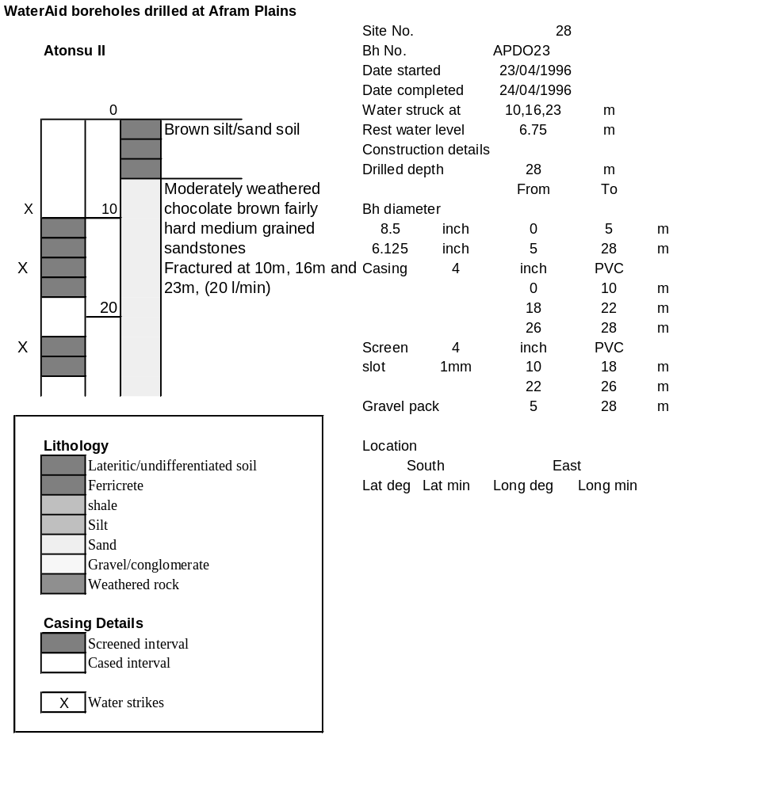

Ghana | Test pumping
Borehole No. |  | APDO23
Hole No |  | 28
Village |  | Atonso II
Date |  | 16/04/1996
Point above GL |  | 0.5 | m
Pump depth |  | 24 | m
SWL |  | 7.25 | m
Start Time |  | 14:20
Drawdown test |  |  |  |  | Recovery test
time | pwl (m) | Q l/min | s (m) | sc | Time | wl (m) | s' (m) | t/t'
0.00 | 7.25 | 40.00 | 0.00 |  | 0.00 | 17.90 | 10.65
1.00 | 9.50 | 40.00 | 2.25 | 17.78 | 1.00 | 13.20 | 5.95 | 181.00
2.00 | 10.05 | 40.00 | 2.80 | 14.29 | 2.00 | 9.40 | 2.15 | 91.00
3.00 | 10.27 | 40.00 | 3.02 | 13.25 | 3.00 | 7.94 | 0.69 | 61.00
4.00 | 10.40 | 40.00 | 3.15 | 12.70 | 4.00 | 7.67 | 0.42 | 46.00
5.00 | 10.49 | 40.00 | 3.24 | 12.35 | 5.00 | 7.60 | 0.35 | 37.00
6.00 | 10.56 | 40.00 | 3.31 | 12.08 | 6.00 | 7.55 | 0.30 | 31.00
7.00 | 10.77 | 40.00 | 3.52 | 11.36 | 7.00 | 7.54 | 0.29 | 26.71
8.00 | 10.93 | 40.00 | 3.68 | 10.87 | 8.00 | 7.53 | 0.28 | 23.50
9.00 | 11.38 | 40.00 | 4.13 | 9.69 | 9.00 | 7.52 | 0.27 | 21.00
10.00 | 11.55 | 40.00 | 4.30 | 9.30 | 10.00 | 7.51 | 0.26 | 19.00
11.00 | 11.86 | 40.00 | 4.61 | 8.68 | 12.00 | 7.49 | 0.24 | 16.00
12.00 | 11.93 | 40.00 | 4.68 | 8.55 | 14.00 | 7.47 | 0.22 | 13.86
13.00 | 12.15 | 40.00 | 4.90 | 8.16 | 16.00 | 7.46 | 0.21 | 12.25
14.00 | 12.34 | 40.00 | 5.09 | 7.86 | 18.00 | 7.45 | 0.20 | 11.00
15.00 | 12.48 | 40.00 | 5.23 | 7.65 | 20.00 | 7.44 | 0.19 | 10.00
16.00 | 12.60 | 40.00 | 5.35 | 7.48 | 22.00 | 7.43 | 0.18 | 9.18
17.00 | 12.69 | 40.00 | 5.44 | 7.35 | 24.00 | 7.41 | 0.16 | 8.50
18.00 | 12.78 | 40.00 | 5.53 | 7.23 | 26.00 | 7.40 | 0.15 | 7.92
19.00 | 12.90 | 40.00 | 5.65 | 7.08 | 28.00 | 7.39 | 0.14 | 7.43
20.00 | 13.05 | 40.00 | 5.80 | 6.90 | 30.00 | 7.38 | 0.13 | 7.00
22.00 | 13.30 | 40.00 | 6.05 | 6.61 | 35.00 | 7.36 | 0.11 | 6.14
24.00 | 13.48 | 40.00 | 6.23 | 6.42 | 40.00 | 7.36 | 0.11 | 5.50
26.00 | 13.70 | 40.00 | 6.45 | 6.20 | 45.00 | 7.35 | 0.10 | 5.00
28.00 | 13.91 | 40.00 | 6.66 | 6.01 | 50.00 | 7.34 | 0.09 | 4.60
30.00 | 14.17 | 40.00 | 6.92 | 5.78 | 60.00 | 7.32 | 0.07 | 4.00
35.00 | 14.57 | 40.00 | 7.32 | 5.46 | 70.00 | 7.31 | 0.06 | 3.57
40.00 | 14.96 | 40.00 | 7.71 | 5.19 | 80.00 | 7.31 | 0.06 | 3.25
45.00 | 15.30 | 40.00 | 8.05 | 4.97 | 90.00 | 7.30 | 0.05 | 3.00
50.00 | 15.59 | 40.00 | 8.34 | 4.80 | 100.00 | 7.29 | 0.04 | 2.80
55.00 | 15.79 | 40.00 | 8.54 | 4.68 | 110.00 | 7.28 | 0.03 | 2.64
60.00 | 15.91 | 40.00 | 8.66 | 4.62 | 120.00 | 7.28 | 0.03 | 2.50
70.00 | 16.16 | 40.00 | 8.91 | 4.49
80.00 | 16.37 | 40.00 | 9.12 | 4.39
90.00 | 16.60 | 40.00 | 9.35 | 4.28
100.00 | 16.80 | 40.00 | 9.55 | 4.19
110.00 | 17.00 | 40.00 | 9.75 | 4.10
120.00 | 17.18 | 40.00 | 9.93 | 4.03
130.00 | 17.37 | 40.00 | 10.12 | 3.95
140.00 | 17.50 | 40.00 | 10.25 | 3.90
160.00 | 17.71 | 40.00 | 10.46 | 3.82
180.00 | 17.90 | 40.00 | 10.65 | 3.76
